Marketing and Public Relations Toolkit

Prepared by: Beth Doyle, Council for Adult and Experiential Learning
Date: December 15, 2014
Contact: bdoyle@cael.org

Purpose of This Toolkit

Promote a Website Provided by the Colorado Community College System
The Colorado Community College System (CCCS) recently launched www.MfgWorksCO.com, an innovative and interactive website designed to help visitors learn about the opportunities in Colorado’s Advanced Manufacturing sector, and how schools in the CCCS system can help them acquire the skills, training and knowledge they need to access these well-paying and fulfilling jobs. The website is part of a broader initiative, the Colorado Helps Advanced Manufacturing Program (CHAMP), and through that initiative we are pleased to offer to you the attached media toolkit. The kit is designed to help you promote the new site and the role your college can play to help more Coloradans get the education and training they need to succeed in advanced manufacturing. We are certain it will be a powerful resource that benefits users and also helps drive enrollment for your institution.

TABLE OF CONTENTS:
- Announcement press release: A draft press release announcing that your college is featured at www.MfgWorksCo.com and the resources available at the site. Customize it for your institution and release it to local publications.  - Backgrounder on Advanced Manufacturing: Information about advanced manufacturing generally; employers, training required, and resources available to help users succeed in the field. This can accompany your press releases so journalists have additional information for reference.  - Generic op-ed: A draft article about the opportunities in Advanced Manufacturing, the resources available at the website and programs offered at your college. Pick an appropriate local publication, decide who should be the author, customize it for your institution and submit it.  - Veteran-focused op-ed: A draft article about how veterans could tap into the opportunities associated with advanced manufacturing, the resources available at the website and the programs available at your college. Pick an appropriate local publication, decide who should be the author, customize it for your institution and submit it.  - Information about going back to school generally: Information about the time and skills requirements, how to fund the experience, etc. This can be shared with prospective students during information sessions, advising sessions or enrollment.  - Social Media tweets and posts: Sample language and graphics that you can use on your social media channels. Select what is most appropriate to your followers and just cut, paste and post.  - Website links: Sample language and logo to add to your school’s website. | 3  5  10  12  14  17  22
Announcement Press Release

_________________________________________________________________________________

FOR IMMEDIATE RELEASE CONTACT: Rhonda Bentz, 303.916.0502
Bitsy Cohn, 720.858.2883
December 16, 2016

COLORADO HELPS ADVANCED MANUFACTURING PROGRAM UNVEILS CAREER WEBSITE:
Site Navigates Users Through Careers in Colorado’s Booming
Advanced Manufacturing Industry

Denver, CO – The Colorado Helps Advanced Manufacturing Program (CHAMP) today launched a new interactive website to help job seekers and college students learn about and transition into careers in Colorado’s booming advanced manufacturing industry, Dr. Nancy McCallin, President, Colorado Community College System announced. The site, MfgWorksCO.com features a suite of interactive tools ranging from Career Maps to Skills Crosswalks to help users better understand the job prospects in advanced manufacturing and the skills and education necessary to take advantage of these growing job opportunities.

In making the announcement, McCallin said, “Today Colorado is in the midst of a manufacturing revolution. Thanks to a surge of new technologies and innovations, today’s manufacturing industry hardly resembles the gritty shop floors of the past. Advanced manufacturing predominantly is centered on innovative technologies and state-of-the art facilities. The industry requires sophisticated skills that translate into rewarding careers and high salaries. We created this site so that users can better understand the opportunities available and the steps they need to take to move into these satisfying and well-paying careers.”

The site: www.MfgWorksCO.com was created by a team that included the Colorado Community College System, the Colorado Workforce Development Council, Manufacturer’s EDGE, The Manufacturing Institute, Council for Adult and Experiential Learning, the Colorado Advanced Manufacturing Alliance, and 28 leading manufacturers in Colorado.
Peter Hancock from Aerotek, a Colorado manufacturing company that helped build the site, said, “There is a tremendous opportunity in advanced manufacturing here in Colorado, but many people still think of the industry in terms of outdated stereotypes that are simply not true. Advanced manufacturing today brings together new technologies and cutting-edge materials to make the products that shape our quality of life and to create new products that will make our lives better.”

Added Stephanie Steffens, Director of the Colorado Workforce Development Council, “We are excited about the resources available at the site, particularly because it all fits in perfectly with the Governor’s Blueprint for economic development within the state. The jobs in advanced manufacturing have the potential to deliver rich, meaningful careers to workers in Colorado who can point with pride at the products they helped create.”

The website is designed for students, workers, and veterans in Colorado to help them learn about the many educational and career opportunities available to move into, or upward, or across, in advanced manufacturing.

Some of the features of the site include:

- Skills Crosswalks, to help workers who seek to move into advanced manufacturing careers understand how the skills they have fit into a new career path and what additional educational training and skills they will need to accomplish the move.
- Job Types with rich detailed job descriptions for workers and students outlining what it is like to work in these advanced manufacturing roles for those who are curious about the kinds of jobs in advanced manufacturing.
- A Career Map which helps the user visualize an entire industry and learn what educational paths to follow to move upward or laterally.
- A special section created specifically for veterans where they can see how the skills and training they acquired while serving our country can help qualify them for a career in advanced manufacturing. Today’s manufacturing jobs are perfect for transitioning service members and veterans who can be employed and live comfortably in a growing career field with relatively little post-service training required.

Added McCallin, “People need to understand the greater role manufacturing employees play in making all the technologies that we rely on to make our lives better, easier, safer and more fun. In addition, not only do manufacturing workers love their jobs, they make a great standard of living. Industry workers enjoy stable, lucrative jobs with opportunity to build a long-term career and this new website is a one-stop-shop where they learn everything they need to embark upon a career in this industry.”

Pamela Tate, CEO and President of the Council for Adult and Experiential Learning, (CAEL), worked closely with Colorado’s advanced manufacturing stakeholders to develop the site. She said, “We were thrilled to work with CCCS and the community’s manufacturing employers to support this important initiative in Colorado. The site is a revolutionary tool and can serve as a national model to help articulate and socialize career pathways to build and strengthen our nation’s workforce. It’s another resource to support our citizens by helping them to link their learning and education to enriching careers in viable industries.”

Concluded McCallin, “We invite you to visit the site and discover your pathway to a rewarding career in advanced manufacturing. You will find job descriptions for dozens of popular positions and profiles of the top employers in Colorado. You will find schools and programs dedicated to helping you achieve your dreams. It is an opportunity to start a new career. Start creating the career of your dreams today and visit www.MfgWorksCO.com.”

CHAMP is led by the Colorado Community College System and is a consortium of colleges, employers, and workforce development stakeholders dedicated to growing the workforce for the advanced manufacturing industry in Colorado through strong industry-education partnerships.

The Colorado Community College System comprises the state’s largest system of higher education serving more than 151,000 students annually. It oversees career and academic programs in the 13 state community colleges and career and technical programs in more than 160 school districts and six other post-secondary institutions.

The Council for Adult and Experiential Learning (CAEL) is a nonprofit 501(c)(3) organization based in Chicago, Illinois that assists adults with their educational endeavors, finding practical ways to help them earn college credit for learning acquired through life and work experiences toward the completion of a postsecondary degree. CAEL works with the public sector, private sector industries, and higher education institutions to ensure that adult students receive the most efficient training and education to occupy a meaningful professional place in a 21st century economy.
###

Backgrounder on Advanced Manufacturing

THE NEW AGE OF MANUFACTURING:
Innovative Careers in Advanced Manufacturing
Shaping a New Future for the Industry

Want to be part of one of today’s hottest fields? Think about advanced manufacturing. From 3-D printing to aerospace, advanced manufacturing might be the ideal career for you.

The Manufacturing Revolution

Welcome to the new age of manufacturing! If you think manufacturing is all about dark hot factories where line workers do monotonous work day after day think again. A surge of new technologies and innovations is creating a computer-driven manufacturing environment that doesn’t even resemble the gritty and grimy shop floors of the past. In fact, manufacturing today is all about advanced technologies, state of the art facilities, and fast paced work environments. Today’s advanced manufacturing industry requires sophisticated skills which also translate into rewarding careers and higher salaries.

Advanced manufacturing is a main driver of innovation in the United States where millions of scientists, engineers and technicians invent and produce new products. It brings together information, automation, computation, software, sensing and networking to create new ways to manufacture existing products, along with completely new ones that emerge from budding ideas and technologies. From workers who use 3-D printing machines to create artificial limbs to inspectors who oversee precision aluminum forgings for the aerospace industry, some of today’s hottest jobs are in advanced manufacturing.

Advanced Manufacturing: Creating the Cool Products that You Love

Advanced manufacturing today is a 21st-century industry that is constantly evolving and offers a variety of dynamic, highly skilled jobs. It’s a technology-driven industry that offers secure, good-paying jobs and the ability to develop products that will change the world. Virtually all the products you can think of that make your life easier, better, safer, and longer – from cell phones to flat screen TVs, smoke detectors and surgical instruments – come from an advanced manufacturing process.

And nowhere is advanced manufacturing growing more than Colorado -- there are currently 680 jobs posted in advanced manufacturing in Colorado and the industry is growing 22 percent faster than the economy as a whole. In fact, Colorado is a national hub of research and development and innovation, and is also home to some of the highest-quality production facilities in the world. Colorado’s manufacturers are creating the revolutionary products of the 21st century that are shaping our quality of life.

According to the Colorado Office of Economic Development and International Trade, the industry is diverse and geographically dispersed across the state, with over 5,900 manufacturing firms, more than 120,000 employees, and $16.3 billion in annual economic output. Today Colorado is at the forefront of advanced manufacturing and is bringing high–paying manufacturing jobs back to the United States.
“The ability to see the tools, touch the products, and speak to the people actually working on the programs, and then walk through a store in the midst of all the made-in-China products and be able to say ‘Hey, see that part? We made that. In Denver. Seeing it first-hand really is something to be proud of.”

Colorado manufacturers are highly innovative and use advanced processes to serve diverse sectors across the Colorado economy - from electronics and consumer products to clean energy systems, aerospace vehicles and medical devices. Manufacturing leaders in the state are also global leaders in advanced materials, as well as food manufacturing and beverage processing.
Nakari
Writing on the Intertech Plastics Blog
Writing on the Intertech Plastics Blog

It’s a new day for manufacturing in Colorado and anyone interested in being part of one of today’s hottest and most interesting fields should think about advanced manufacturing. The facilities of today and tomorrow are clean and replete with robots, computers, lasers, and other ultramodern machine technologies. Digital technology is transforming manufacturing, making it leaner and smarter—and raising the prospect of an American industrial revival. Even better, the opportunities for innovation and highly-skilled, high paying jobs in advanced manufacturing are boundless. An advanced manufacturing job can provide unparalleled benefits and encourages workers to pursue the skills that will lead to a long-term career with security and professional growth. It’s an opportunity not to just find a job but to start a new career.

Facts about Advanced Manufacturing

- There are currently 680 jobs posted in Advanced Manufacturing in Colorado
- Advanced Manufacturing is growing 22 percent faster than the economy as a whole

Giving Back to the Community
The advanced manufacturing field is making the world a better place by having a positive impact on our community. The industry is clean and green.

Things We’re Doing

Many Colorado manufacturers are clean and green and doing their part to make the world a better place. And there are terrific examples of manufacturers giving back to the community by giving a portion of their proceeds to charity or allowing employees time-off to volunteer. Colorado is home to manufacturers that are socially responsible and generally spreading good. Here are some examples of how Colorado’s manufacturing employers are helping communities:

- AirGas has an ongoing commitment to Operation Homefront on a local and national level. They also offer the Airgas “Welding 101” course at no cost to any veteran of Iraq and Afghanistan service who is interested in exploring a career in welding.
- AeroTek is committed to supporting education in the Science, Technology, Engineering and Mathematics (STEM) disciplines.
- Trane Pueblo takes part in Neighborhood Works and participates in Operation Paintbrush to repaint & rehabilitate the homes of those who cannot do so for themselves.
- Vestas is the global wind leader and their employees are excited about the commitment to making the world’s energy mix more sustainable.
- MillerCoors created FEWER (Fuel, Energy, Water, Emissions Reduction) Teams, with representatives at each brewery, that have multi-year action plans to improve results.

From caring about their employees to caring about the environment, manufacturing companies have a big positive impact.

Advanced Manufacturing Career Map

For those interested in exploring a career in advanced manufacturing, the Colorado Helps Advanced Manufacturing Program (CHAMP) has created an innovative and interactive website, www.MfgWorksCO.com to help users navigate through careers in the industry. At the site you’ll find everything you need to know about the industry including the Career Map where the user can visualize an entire industry and learn what educational paths to follow to move upward or laterally. It also includes a host of job descriptions for dozens of popular positions for those who are interested in learning about the kinds of jobs that the industry offers.

Employers Who Care

Manufacturing companies invest in their employees and offer dynamic, good paying jobs that can easily turn into rewarding careers. Today’s manufacturing companies know how valuable a skilled employee is and work hard to make sure that their employee’s skills stay up to date and their occupational needs are met.

Employers know that to attract and keep the best in the industry, their pay and benefits must be competitive. This means stable employment and great pay are only the beginning for manufacturing workers.

Education, Training and Industry Certifications That Count

Whether you are 53 or 18 you can enjoy a rewarding career in advanced manufacturing but additional education and training are important. It will help you either prepare for a job in the industry, advance your career by staying up-to-date with current technology, or help you become more valuable to your current employer.

To help you on your path, these schools offer specialized education:

Aims Community College
Red Rocks Community College
Community College of Denver
Morgan Community College
Front Range Community College
Arapahoe Community College
Pikes Peak Community College
Community College of Aurora
Pueblo Community College
Colorado Northwestern Community College
Otero Junior College
Lamar Community College
Colorado Community Colleges Online
Northeastern Junior College
Trinidad State Junior College

Industry Certification Providers
American Society for Quality
American Society of Transportation and Logistics
American Welding Society
Association for Operation Management
Fabricators and Manufacturers Association, International
International Fluid Power Society
Examples of Advanced Manufacturing in Colorado:
- Engaging in Creativity through an innovation incubator inventing new products to help kids learn, create, write and imagine including “heat-activated pens” with colors that change when exposed to heat.
- Specialty Ink Innovator for Cans that light up when the temperature for consuming their contents is just right.
- Security Applications that help government agencies and brands authenticate documents, currency and brands using technology for documents that changes color or ink that disappears with a touch of a finger
- Food Safety Awareness. Special “return to fridge” alerts when a product has been left too long outside the refrigerator.
- 3D Printing Systems to build scaled-down prototypes of intricate parts.
- Flight Control Systems & cockpit controls.
- Products for Deep Water production facilities and subsea pipelines

International Society of Automation
Manufacturing Skill Standards Council
National Institute for Metalworking Skills
North American Die Casting Association
Packaging Machinery Manufacturing Institute
Project Management Institute
Society of Manufacturing Engineers

Generic Op-Ed
ADVANCED MANUFACTURING IS BOOMING IN COLORADO:
Interactive Website and (Name of School) Can Help You Navigate To Lucrative and Rewarding Careers in Advanced Manufacturing

If you think manufacturing is a dead-end industry that’s all about dark factories where line workers do monotonous work day after day think again. In fact, today’s manufacturing industry is not only booming but hardly resembles the gritty and grimy shop floors of the past. A surge of new technologies and innovations is creating a computer-driven environment that is all about advanced technologies, state of the art facilities, and fast paced work environments. And now, thanks to a new website that features (Name of School,) students and adults have an innovative and interactive resource at www.MfgWorksCo.com that can help them learn everything they need to know to help them transition into these long-term rewarding and lucrative careers.

Nowhere is the promise of advanced manufacturing brighter than here in Colorado -- there are currently 680 jobs posted in Advanced Manufacturing in Colorado and the industry is growing 22 percent faster than the economy as a whole. In fact, Colorado is a national hub of R&D and innovation, and is also home to some of the highest-quality production facilities in the world. From surgical devices, robotics and flat panel TVs, to space vehicles and flight deck controls, Colorado’s manufacturers are creating the revolutionary products of the 21st century that are shaping our quality of life.

Such a promising landscape can deliver better and more rewarding careers for those that understand the opportunity, but the right education and training are critical for success. By visiting the website users can understand how to move into, or upward, or across various career paths and into these opportunities in advanced manufacturing and specifically how we at (Name of School) can help them succeed. At the site visitors will find innovative and interactive tools like “Crosswalking” designed to help workers in one industry understand the skills and educational credentials necessary if they want to move to another industry and what classes they will need to take to move into those careers. Another interactive tool is the Career Map where the user can visualize an entire industry and learn what educational paths to follow to move upward or laterally. It also includes a host of job descriptions for dozens of popular positions for those who are interested in learning about the kinds of jobs that the industry offers, along with profiles of the top employers in Colorado. The user can then match up the skills they will need with the programs we have here at (Name of School) that can help them achieve their dreams of a career in the industry.

The site also includes a special section dedicated specifically to veterans where they can see how the skills and training they acquired while serving our country can help qualify them for a career in advanced manufacturing. Here at (Name of school) we have a number of programs that can help veterans transition into these careers including (programs or other benefits of value to veterans.) Today’s manufacturing jobs are perfect for transitioning service members and veterans who can be employed and live comfortably in a growing career field with relatively little post-service training required.

Exploring new career opportunities can be exciting but it can be daunting, too. That’s why our admissions officer at (Name of School) are always available to work with students to help them map out a curriculum that works best for them. We work to identify specific career-relevant education and training options, online learning choices, and industry-recognized credentials that help prepare them for great jobs and an exciting future in advanced manufacturing.

Most people don’t realize the greater role manufacturing employees play in making all the cool stuff that we rely on to make our lives better, easier, safer and more fun. And from (name of program) to (name of program) those interested in pursuing a career in advanced manufacturing can learn everything they need to succeed here at (Name of School.) It’s an exciting opportunity to be part of one of today’s hottest and most interesting fields. So don’t wait! Visit www.MfgWorksCo.com today and see how (Name of School) can help create the career of your dreams.

Veteran-focused Op Ed
FROM THE MILITARY TO ADVANCED MANUFACTURING:
Interactive Website and (Name of School) Can Help You Navigate To Lucrative and Rewarding Careers in Advanced Manufacturing

Veterans transitioning out of the service and into civilian life typically face many obstacles, not the least of which is understanding how to translate their highly specialized skills and training into ones that employers are seeking in a civilian workplace environment. In addition, for many veterans who spent years serving in the military, just thinking about what to do next can be a daunting task. Now, thanks to a new website that features (Name of School) they have an innovative and interactive resource at www.MfgWorksCo.com that can help them learn everything they need to know to help them transition into one of the hottest growing job sectors in Colorado: advanced manufacturing.

While many think that manufacturing is a dead-end industry that’s all about dark factories where line workers do monotonous work day after day, nothing could be further from the truth. In fact, today’s manufacturing industry is not only booming but hardly resembles the gritty and grimy shop floors of the past. A surge of new technologies and innovations is creating a computer-driven manufacturing environment that is all about advanced technologies, state of the art facilities, and fast paced work environments.

The website is designed to help users understand how to move into, or upward, or across various career paths and into these opportunities in advanced manufacturing and how we here at (Name of School) can help prepare them for those jobs. At the site visitors will find innovative and interactive tools like “Crosswalking” designed to help them understand the skills and educational credentials necessary if they want to move to another industry. Another interactive tool is the Career Map where the user can visualize an entire industry and learn what educational paths to follow to move upward or laterally. It also includes a host of job descriptions for dozens of popular positions for those who are interested in learning about the kinds of jobs that the industry offers, along with profiles of the top employers in Colorado. Veterans can then match up the skills they will need with the programs here at (Name of School) so they can achieve their dream of a rewarding career in an industry that is growing and holds great promise for the future.

Perhaps most helpful, the site also includes a special section dedicated specifically to veterans where they can see how the skills and training they acquired while serving our country can help qualify them for a career in advanced manufacturing. It also includes links to help veterans evaluate their skills, training and experience to see if they might be eligible for college credit. Here at (Name of School) we have a number programs that can help veterans transition into these careers including (programs or other benefits of value to veterans.) Today’s manufacturing jobs are perfect for transitioning service members and veterans who can be employed and live comfortably in a growing career field with relatively little post-service training required.

Best of all, nowhere is the promise of advanced manufacturing brighter than here in Colorado -- there are currently 680 jobs posted in advanced manufacturing in Colorado and the industry is growing 22 percent faster than the economy as a whole. In fact, Colorado is a national hub of R&D and innovation, and is also home to some of the highest-quality production facilities in the world. From surgical devices, robotics and flat panels, to space vehicles and flight deck controls, Colorado’s manufacturers are creating the revolutionary products of the 21st century that are shaping our quality of life.

Exploring career opportunities can be exciting but it can be intimidating too which is why here at (Name of School) our admissions officers are always available to work with students to help them map out a curriculum that works best for them. We work to identify specific career-relevant education and training options, online learning choices, and industry-recognized credentials that help prepare them for great jobs and an exciting future in advanced manufacturing.

Many of the skills required in the military are the very same ones that are in demand in today’s advanced manufacturing industry, and veterans interested in being part of some of today’s hottest and most interesting fields should consider it and (Name of School) for their career. It’s a chance to work with ultra-modern machine technologies ranging from computer systems and robots to lasers and 3-D printers to create the products of tomorrow. It’s the chance to say “I helped make that.” An advanced manufacturing job can provide unparalleled benefits and an environment where veterans can pursue the skills and training that will lead to a long-term career with security and professional growth. It’s an opportunity not to just find a job but to start the next chapter of life with a new career.

Information About Going Back to School

Are You Ready to Go Back to School?

Going back to school is certainly exciting but it also requires a tremendous amount of time and hard work and it is important to make sure that you really do have the time and are ready to make the commitment.

The first thing you should do is decide what kind of career you want and what educational credentials you will need. One resource you can visit is www.MfgWorksCO.com for advanced manufacturing that will help you explore different career options and learn what educational paths you need to follow in order to move upward or laterally.

Do you have the time?

Even if you start with just one class, going back to college will change your schedule dramatically. In addition to actually sitting in on the classes, you’ll need time to study materials, prepare for classes and complete assignments. Make sure you have thought carefully about your schedule and how it could be altered so that you’ll be sure to have the time you need to succeed.

Do you have adequate computer skills?

If you are going back to college you need to be competent on a computer. If you’re a little behind on those skills you’ll need to spend some time updating them because today they play a significant role in day-to-day life of a student. Knowing your way around a computer is a must for any college student because schools today rely heavily technology. You will need computer skills to communicate with your instructors and for research, essays, and exams. If you need help brushing up on these skills, there are many online courses you can take to help to learn how to use critical programs including Word, Excel and PowerPoint.

Are you intimidated by the idea of going back to college?

Whether you’re wondering about how you might fit in with younger students or whether you will do well in your classes, you are not alone. However, according to the National Center for Education Statistics there are more than eight million adults over the age of 25 who are pursuing a college degree. Most likely they all had the same concerns you have so you are not alone. In addition, adult students typically perform better than their younger counterparts because they usually go back to school with more determination and motivation. They also tend to have a clearer idea of how, exactly, the college degree will help them in other areas of their life.

Are You Eligible for Prior Learning Credits?
Did you know that you may be eligible to earn college credit for experience and skills you already have? Perhaps you did volunteer work that taught you accounting skills, or maybe you speak Spanish natively. In fact there are a number of resources available that can help you evaluate learning and skills that you already have that may be eligible for college credit.
Credit (or other recognition) students can earn for their prior learning can be determined through several different types of assessments. There are four generally accepted approaches to Prior Learning Assessment (PLA):

- Standardized exams such as: Advanced Placement Examination Program (AP exams); College Level Examination Program Exams (CLEP exams); Excelsior College Exams (UExcel); and the DANTES Subject Standardized Tests, or DSST Exams

- Evaluated non-college programs. The National College Credit Recommendation Service (NCCRS) and the American Council on Education (ACE) conduct evaluations of training that is offered by employers or the military. Many employers also work directly with local postsecondary institutions to evaluate their companies’ training. The result of these evaluations is credit recommendations for anyone satisfactorily completing that training.

- Individualized assessments. In this method, students prepare a portfolio or demonstration of their learning from a variety of experiences and non-credit activities. Then, faculty with appropriate subject matter expertise evaluate the student’s portfolio to determine a credit award.

- College faculty-developed exams, also called “challenge exams,” allow students to earn credit by taking examinations faculty create for courses offered at a given institution.

You can learn more about Prior Learning Assessment options with your college’s admissions or student services office where they can direct you to the resources that best match your needs and background.

Tips to Help You Pay for Your Degree
One question you need to ask yourself is how you will pay for classes. What many people don’t realize is that money for college is available for every single student attending a public or private institution of higher learning in the US, and that means YOU!

There are lots of ways to pay for college – out of pocket, loans, scholarships, tuition reimbursement programs through employers, the GI Bill. Do a detailed budget and understand what your funding sources are and how much you will need exactly. Don’t forget to budget for other out-of-pocket expenses such as books, transportation and possibly a babysitter.

Learning about financial aid options doesn’t cost anything either. You can begin by visiting www.fafsa.ed.gov and you can also make an appointment at your school’s financial aid office to see how they can help you return to school. You’ll need to bring your tax returns to help them evaluate how much money you’ll need to make school a reality.

Check with your employer.

In many instances employers will have tuition assistance programs, so if you have a job you should meet with someone in the HR office to learn more about what might be available. Many employers that offer tuition reimbursement programs require employees to take a certain number of classes before they are reimbursed or to maintain a certain grade point average, so make sure you understand exactly what will be expected of you in order for you to be reimbursed.

Make sure you investigate scholarships carefully.

Many students don’t apply for scholarships because they think the competition would be overwhelming, but the sad truth is that there are scholarships available every year with no applicants. In fact, you should apply for every scholarship you can find. Think about schools, employers, individuals, private companies, nonprofits, communities, religious groups, and professional and social organizations.

Specifically, you might check with:

- The financial aid office at your college
- Your library’s reference librarian
- Foundations, religious or community organizations, local businesses, or civic groups
- Organizations (including professional associations) related to your field of interest
- Ethnicity-based organizations
- Your employer

Finally, keep in mind that financial aid is intended to pay for tuition, school fees, and books, but you can also use it for other expenses you may have including transportation and childcare.

Social Media Tweets and Posts
Introduction
We have purposely distributed this toolkit in Microsoft Word so that you can save the images to your desktop and then upload to the social media platform of your choice. Note: images are depicted smaller than their actual size. Feel free to use as many as you wish and tailor the text as you see fit.
To unify the buzz, please use the hashtag #MFGChamp. Use the hashtag in any social media messages you use and ask others to share to increase the visibility and spread the word even further.

VIDEO: Check out the 60-second video to help drive users to the site at https://www.cccs.edu/partnering-for-success/trade-adjustment-assistance/taa-champ/taa-champ-resources/.

Sample Tweets
#Colorado is booming with #jobs in advanced manufacturing. Learn more at http://ittybitty.bz/mfgworks
There are a variety of jobs in Advanced #Manufacturing. Learn about the most exciting & growing ones: http://ittybitty.bz/jobtypes
6% of #Colorado jobs are in #manufacturing. That's 120k+ manufacturing #jobs http://ittybitty.bz/mfgworks
Changing careers? #Manufacturing needs you! 7 in 10 manufacturers need additional skilled workers. http://ittybitty.bz/mfgworks
#Colorado is one of the Top 20 states in manufacturing job creation http://ittybitty.bz/jobtypes
Pursue industry certifications & credentials w/out breaking the bank. Open doors to #career options http://ittybitty.bz/education
Pursue respected industry certifications & credentials. Open the door to #career options galore http://ittybitty.bz/education
#Education is an adventure. #Colorado schools can help advance skills in emerging fields http://ittybitty.bz/education
#Education is an adventure. #Colorado schools can help you reach your career #goals http://ittybitty.bz/education
Earn credentials to increase your value in #manufacturing, validate how much knowledge you have http://ittybitty.bz/education
Not sure where to start w/ your #manufacturing #career? See what skills you already have: http://ittybitty.bz/onestop
Are you an adult returning to #school? Check out Savvy Strategies for Returning to School: http://ittybitty.bz/strategies
Going back to school is a BIG decision that can change your life. Take your time, research & ask questions. http://ittybitty.bz/education
Today’s trivia: 7k+ new production #jobs will be added by 2022. http://ittybitty.bz/mfgworks
Do you know that 16,000 Advanced #Manufacturing #jobs go unfilled each year? http://ittybitty.bz/mfgworks
#Colorado companies are buzzing with latest & greatest technologies. Learn more about manufacturing #jobs http://ittybitty.bz/mfgworks
Unsure what Advanced #Manufacturing in #Colorado has in store for you? Take a look: http://ity.vc/covideo
Trivia Tuesday: Colorado is home to 5900 manufacturing companies. Learn more: http://ittybitty.bz/mfgworks
#Manufacturing employers spend millions on employee #education, does yours? http://ittybitty.bz/education
What can you do with a job in Advanced #Manufacturing in Colorado? Find out: http://ity.vc/covideo

Sample Posts
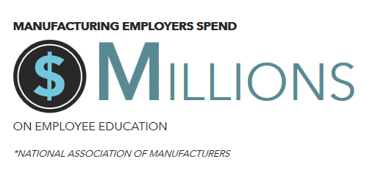
Does your employer invest in your education? Manufacturing employers do!
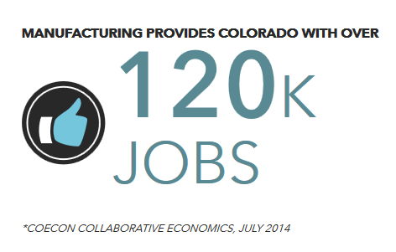
Looking for a job, why not explore a career in advanced manufacturing?

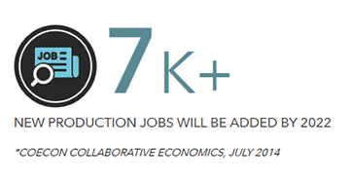
Not sure what your current career prospects are, there are endless possibilities available in advanced manufacturing. Explore the possibilities: http://ittybitty.bz/jobtypes
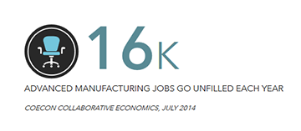
That’s a startling figure! Explore the different types of jobs available and get started on your new career today: http://ittybitty.bz/jobtypes

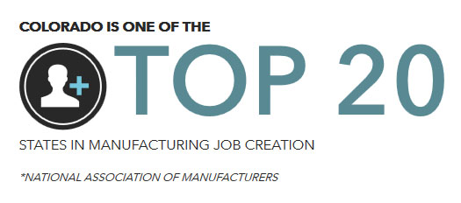
You’re in one of the best states for advanced manufacturing, explore career options today!

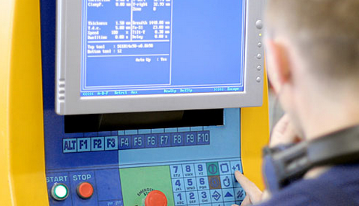
CNC machine programmers develop programs that tell automatic machine tools, equipment, or systems how to work. Learn more: http://ittybitty.bz/machine

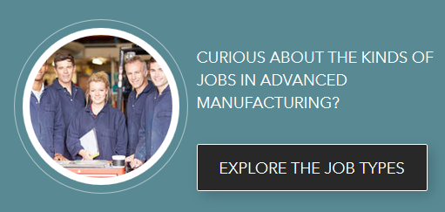
Learn more about different job types at http://ittybitty.bz/jobtypes.

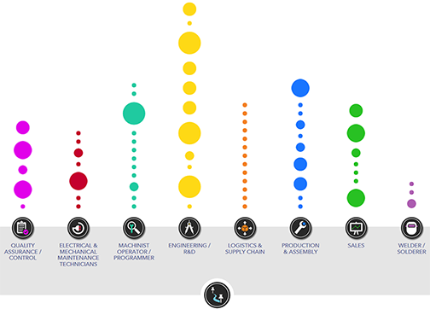
Unsure of the different types of jobs advanced manufacturing offers, explore our career map and get your questions answered: http://ittybitty.bz/carmap

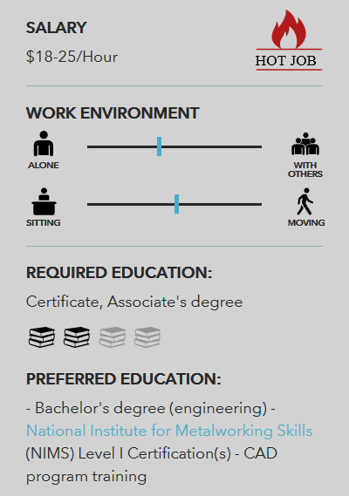
Want to know what jobs are hot and the education required? Explore career maps: http://ittybitty.bz/carmap

Website links
Introduction
In order to leverage this resource, we want to make it is as accessible and available as possible. One way to do that is to add a link to this site to your school’s website. Links can be added to Career Services, Advising, and Manufacturing program webpages. Use any of the descriptions or images found in this toolkit. Here are some examples:

Learn about Colorado’s advanced manufacturing industry. Use interactive tools to explore jobs, skills crosswalks, career maps, employers, and education.

Where are the jobs in advanced manufacturing? Find out where the jobs are in Colorado, industry information, career maps, salaries, and education at www. MfgWorksCO.com.

VIDEO: Link to a 60-second video to help promote the site at https://www.cccs.edu/partnering-for-success/trade-adjustment-assistance/taa-champ/taa-champ-resources/.

